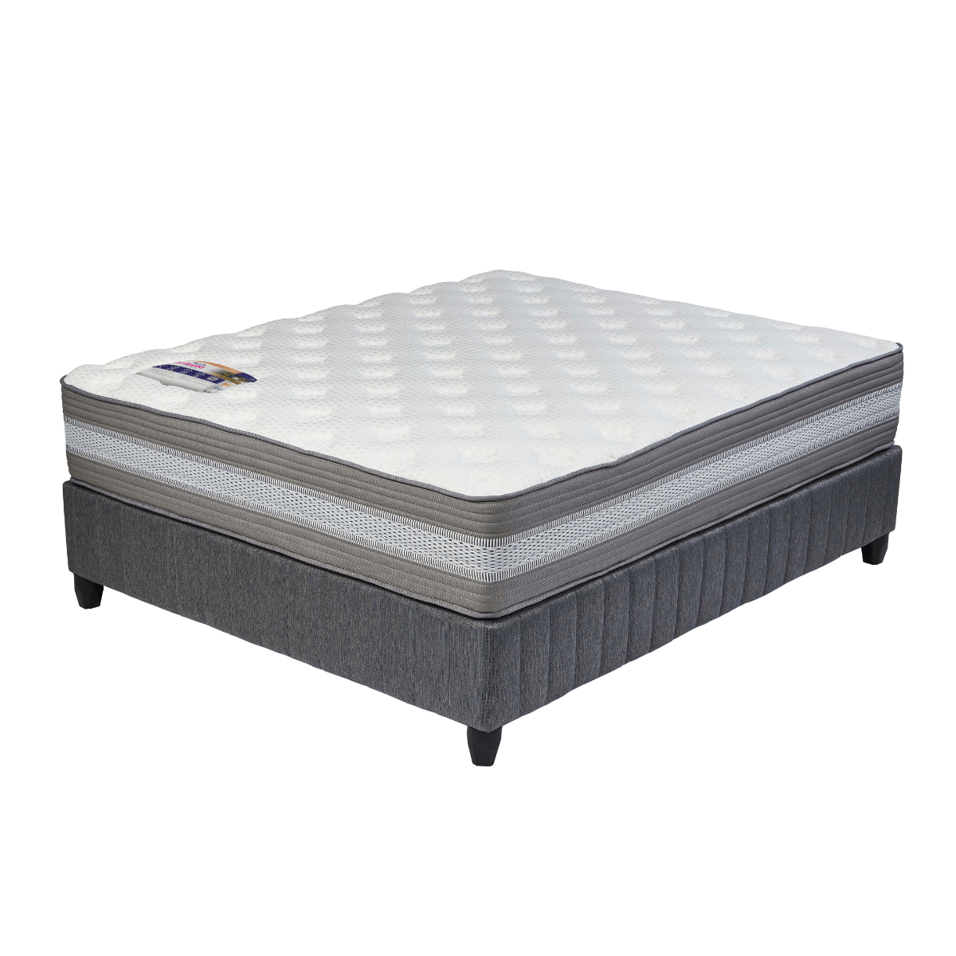
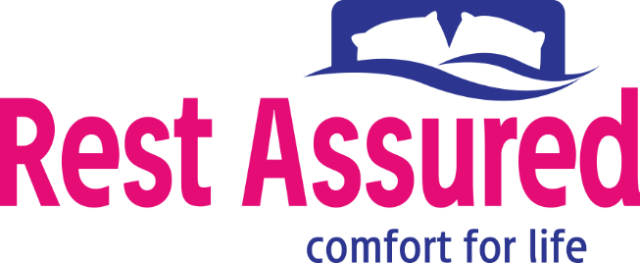

Model : Body Balance Base Set
Supplier/Manufacturer : Rest Assured
Range : Evolution Pocket Spring Collection
Prices – Bed Set :
- Single Bed Set – R11099
- Three Quarter Bed Set – R12639
- Double Bed Set – R15189
- Queen Bed Set – R16499
- King Bed Set – R20379
Prices – Mattress Only :
- Single Mattress Only – R9449
- Three Quarter Mattress Only – R10809
- Double Mattress Only – R13159
- Queen Mattress Only – R14419
- King Mattress Only – R17069
Prices - Extra Length Bed Set :
- Single Extra Length Bed Set – R11989
- Three Quarter Extra Length Bed Set – R13649
- Double Extra Length Bed Set – R16409
- Queen Extra Length Bed Set – R17819
- King Extra Length Bed Set – R22009
Prices - Extra Length Mattress Only :
- Single Extra Length Mattress Only – R10209
- Three Quarter Extra Length Mattress Only – R11679
- Double Extra Length Mattress Only – R14219
- Queen Extra Length Mattress Only – R15579
- King Extra Length Mattress Only – R18439

*Please use this link for guideline for creating the page* - https://www.bedsonline.co.za/product/rest-assured-body-balance-queen/
Rest Assured Link - https://restassured.co.za/our-ranges/evolution/body-balance/

